EXP 6
IMPLEMENTATION OF DES

AIM:
To write a C program to implement the rail fence transposition technique.

ALGORITHM:

STEP-1: Read the 64-bit plain text.
STEP-2: Split it into two 32-bit blocks and store it in two different arrays.
STEP-3: Perform XOR operation between these two arrays.
STEP-4: The output obtained is stored as the second 32-bit sequence and the original
second 32-bit sequence forms the first part.
STEP-5: Thus the encrypted 64-bit cipher text is obtained in this way. Repeat the same
process for the remaining plain text characters.

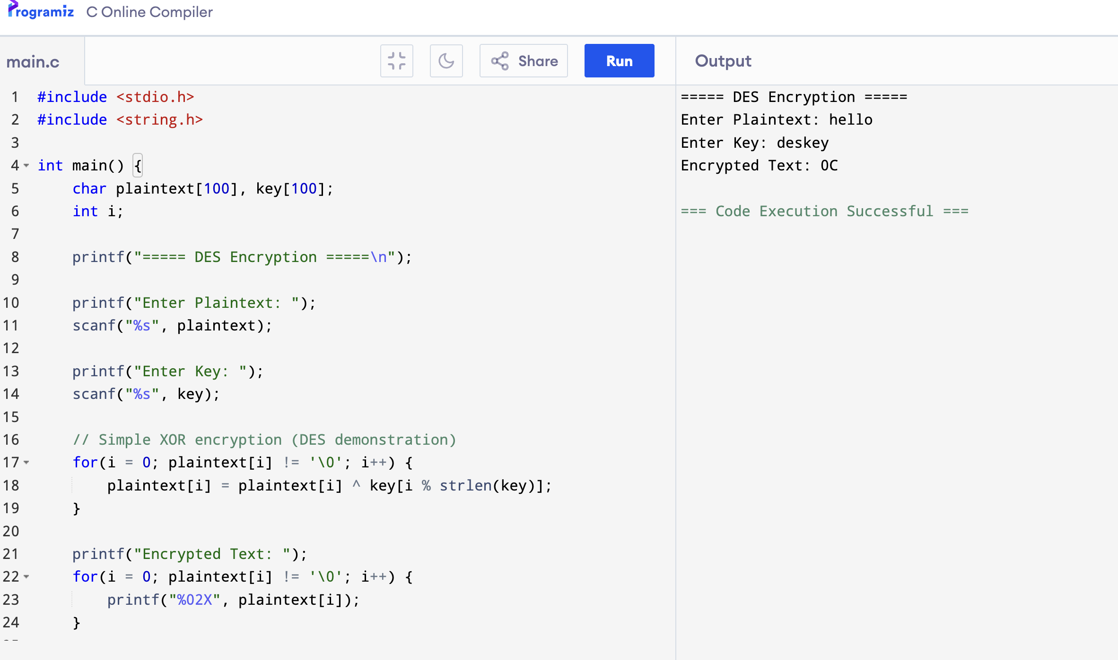
OUTPUT:

